SOFTWARE REQUIREMENTS
SPECIFICATION (SRS)
[Project / System Name]
Version | [e.g., 1.0]
Prepared By | [Name / Team]
Prepared For | [Client / Instructor]
Date | [Month Day, Year]
Course | [Course Code / Title, e.g., ADET]
Based on Unit 1: Requirement Analysis and Modeling

Revision History
Date | Version | Description | Author
[dd/mm/yyyy] | [1.0] | [Initial draft] | [Name]
[ ] | [ ] | [ ] | [ ]

Table of Contents
[ Right-click and choose 'Update Field' after editing this document to refresh the Table of Contents. ]

1. Introduction
This section provides an overview of the entire Software Requirements Specification (SRS) document. It describes the purpose, scope, intended audience, and definitions used throughout the report, laying the foundation for the software engineering activities that follow.

1.1 Purpose
[ State the purpose of this SRS document and identify the intended readers (e.g., developers, testers, project managers, client). ]

1.2 Scope
[ Identify the software product to be produced, what it will and will not do, and its intended use. Relate the software to overall business or project objectives. ]

1.3 Definitions, Acronyms, and Abbreviations
[ Define all terms, acronyms, and abbreviations used in this document to ensure interpretations are correctly understood. ]
Term / Acronym | Definition
[e.g., SRS] | [Software Requirements Specification]
[ ] | [ ]

1.4 References
[ List any documents or resources referenced in the SRS (standards, related project documents, links, etc.). ]
- [Reference 1]
- [Reference 2]

1.5 Overview
[ Describe what the rest of the SRS document contains and how it is organized. ]

2. Overall Description
This section describes the general factors that affect the product and its requirements, providing background rather than detailed specifications.

2.1 Product Perspective
[ Describe the context and origin of the product. State whether it is a new, self-contained product or a component of a larger system. ]

2.2 Product Functions
[ Summarize the major functions the product will perform. A simple list or a diagram is often sufficient here. ]
- [Function 1]
- [Function 2]

2.3 User Classes and Characteristics
[ Identify the different types of users the system is intended for (e.g., Admin, Customer, Staff) and describe their relevant characteristics. ]
User Class | Description
[e.g., Administrator] | [Description of role and privileges]
[ ] | [ ]

2.4 Operating Environment
[ Describe the environment in which the software will operate, including hardware platform, operating system, and other software components. ]

2.5 Design and Implementation Constraints
[ List any constraints on the design (e.g., regulatory policies, hardware limitations, specific technologies, languages, or database integrity policies). ]

2.6 Assumptions and Dependencies
[ List any assumed factors (as opposed to known facts) that could affect the requirements stated in the SRS. ]

3. Functional Data Description
[ Describe the data used and produced by the system's functions, including data flow between processes. ]

3.1 Input/Output
[ Describe the required inputs and expected outputs of the system's major functions. ]

3.2 Processing
[ Describe how inputs are processed and transformed into outputs. Include process descriptions or algorithms as needed. ]

3.3 Error Handling
[ Describe how the system detects, reports, and recovers from error conditions. ]

4. Specific Requirements
This is the core of the SRS document, containing all software requirements to a level of detail sufficient to enable designers to design and testers to test the system.

4.1 Functional Requirements
[ List the functional requirements in sufficient detail for designers to design a system and testers to verify system behavior. Group by feature/module and use a unique ID for traceability. ]
ID | Requirement Description | Priority | Source
FR-01 | [The system shall ...] | [Essential / Conditional / Optional] | [Stakeholder]
FR-02 | [ ] | [ ] | [ ]

4.2 Non-Functional Requirements
[ Describe the quality attributes and constraints of the system. Sub-sections below correspond to common non-functional requirement categories. ]

4.2.1 Physical Environment
[ Describe equipment locations, multiple sites, environmental conditions, etc. ]

4.2.2 Interfaces
[ Describe data medium and format for information exchange between system components or external systems. ]

4.2.3 User and Human Factors
[ Describe who the users are and their skill levels, training needs, and accessibility considerations. ]

4.2.4 Performance
[ Specify how well the system must function (e.g., response time, throughput, capacity). ]

4.2.5 Documentation
[ Describe the documentation to be delivered with the system (user manuals, technical docs, etc.). ]

4.2.6 Data
[ Describe qualitative data requirements, such as data retention, format, and volume. ]

4.2.7 Resources
[ Describe resource requirements such as physical space, funding, or staffing. ]

4.2.8 Security
[ Describe backup, firewall, authentication, authorization, and other security requirements. ]

4.2.9 Quality Assurance
[ Specify quality metrics such as maximum downtime, mean time between failures (MTBF), etc. ]

4.3 External Interface Requirements

4.3.1 User Interfaces
[ Describe the logical characteristics of each interface between the software and its users, including screen layouts, error message formats, and standard buttons/functions (e.g., Help). ]

4.3.2 Hardware Interfaces
[ Describe the logical and physical characteristics of each interface between the software and hardware components. ]

4.3.3 Software Interfaces
[ Describe connections between this product and other software components (databases, operating systems, tools, libraries). ]

4.3.4 Communications Interfaces
[ Describe requirements for communication functions the product will use, such as network protocols. ]

5. Subsystem Description
[ Decompose the system into subsystems or modules. Describe the purpose and responsibilities of each subsystem, and how the subsystems interact with each other. ]
Subsystem | Description
[e.g., User Management] | [Responsibilities and key functions]
[ ] | [ ]

6. System Modeling and Simulation Results
This section presents the graphical models developed during requirement analysis to represent the structural and behavioral design of the system.

6.1 Data Flow Diagram (DFD)
[ Sample Context Diagram (Level 0) and Level 1 DFD are shown below as a guide. Replace the entities, processes, data stores, and data flow labels with those of your own system. ]
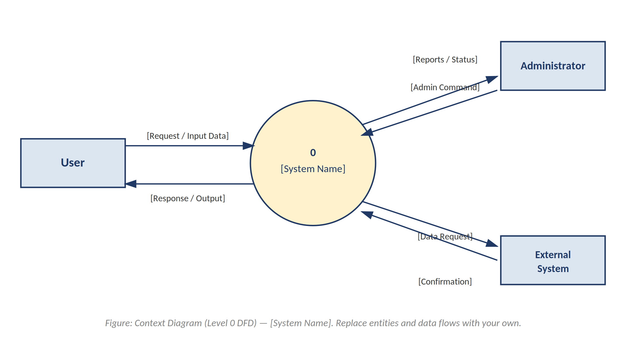
Figure 6.1.1 — Context Diagram (Level 0 DFD)
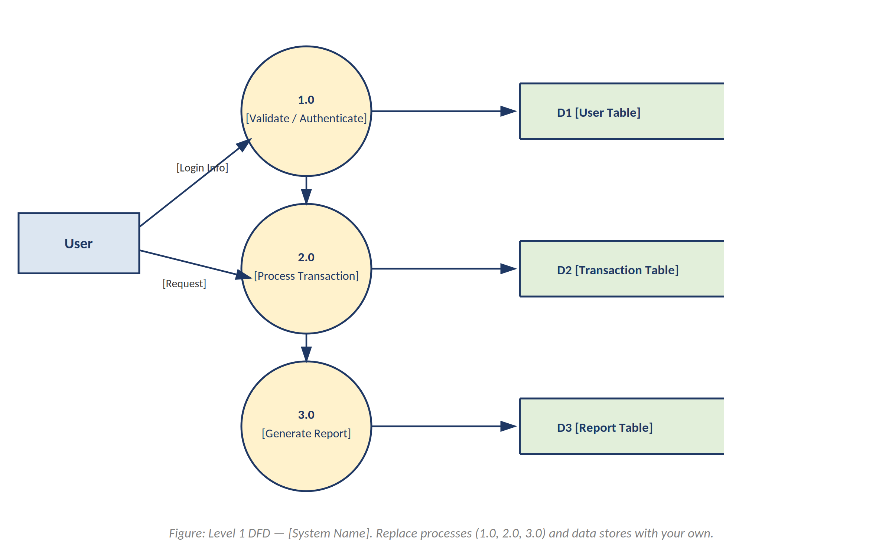
Figure 6.1.2 — Level 1 DFD

6.2 Entity Relationship Diagram (ERD)
[ A sample ERD is shown below as a guide. Replace the entities, attributes (PK/FK), and relationships (1:1, 1:M, M:M) with those of your own database design. ]
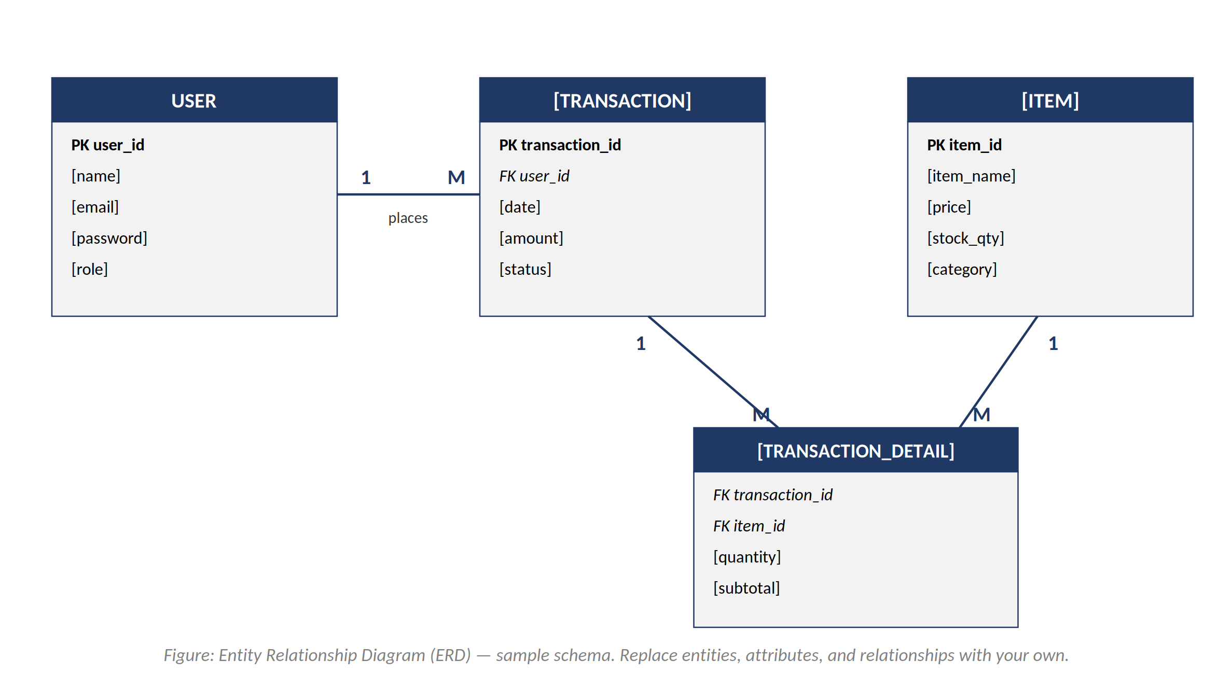
Figure 6.2.1 — Entity Relationship Diagram (ERD)

6.3 Data Dictionary
[ Provide a Data Dictionary File describing each data element, its type, size, and description, used for database design. ]
Field Name | Data Type | Size | Description
[e.g., user_id] | [INT] | [11] | [Unique identifier for user]
[ ] | [ ] | [ ] | [ ]

6.4 Simulation / Modeling Results
[ Summarize any simulation outputs, prototypes, or modeling results validating the requirements. ]

7. Products
[ List the deliverable products of this project phase (e.g., source code, executable, documentation, test plans, training materials). ]
- [Deliverable 1]
- [Deliverable 2]

8. Other Analysis Models
[ Optional: include additional models used during analysis, such as Use Case Diagrams, Class Diagrams, or State Transition Diagrams, if applicable to your project. ]

9. Appendices

9.1 Appendix A: Glossary
[ Provide any additional glossary items not covered in Section 1.3. ]

9.2 Appendix B: Analysis Models
[ Attach supplementary analysis models, diagrams, or supporting documents. ]

9.3 Appendix C: Issues List
[ List open issues, unresolved requirements, or items requiring further clarification with the client/stakeholders. ]

— End of Document —

